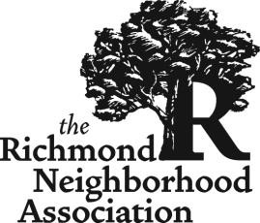

Agenda Request Form
RNA meetings are the 2nd Monday of the Month, except no meeting in January
http://richmondpdx.org/

Name:
Email: |  |  |  |  |  | Phone number:
Organization you are representing:
Date: | Click or tap to enter a date.
Agenda Topic:

Do you want:
☐ Letter of Support?
If yes, please submit a draft letter of support if you have one.
☐ Donation of Money?
If yes, how much:

☐ Provide information only?

If you are seeking a Letter of Support or Donation Request, have you read the RNA's Donations and Letters of Support Guidelines? Y ☐ / N ☐

How much time do you need to present on this topic, including expected Q & A?:

How time sensitive is this matter: Are you under a specific deadline by when the RNA needs
to address this, if so what is it?

Send this completed form to: the RNA Chair richmond.pdx.chair@gmail.com and Secretary richmondnasecretary@gmail.com

Please note: Under the RNAs’ guidelines for donations and letters of support, we need any draft letters of support or materials you want to submit a week before the meeting.

